**A soil moisture sensor can read the amount of moisture present in the soil surrounding it. It is ideal for monitoring garden, or your plant's water level. This is a must have tool for a connected garden.**

**This sensor uses the two probes to pass current through the soil, and then it reads that resistance to get the moisture level. More water makes the soil conduct electricity more easily (less resistance), while dry soil conducts electricity poorly (more resistance).**

**It will be helpful to remind you to water your indoor plants or to monitor the soil moisture in your garden. The IO Expansion Shield is the perfect shield to connect this senor to Arduino.**

**The new soil moisture sensor uses Immersion Gold which protects the nickel from oxidation.**

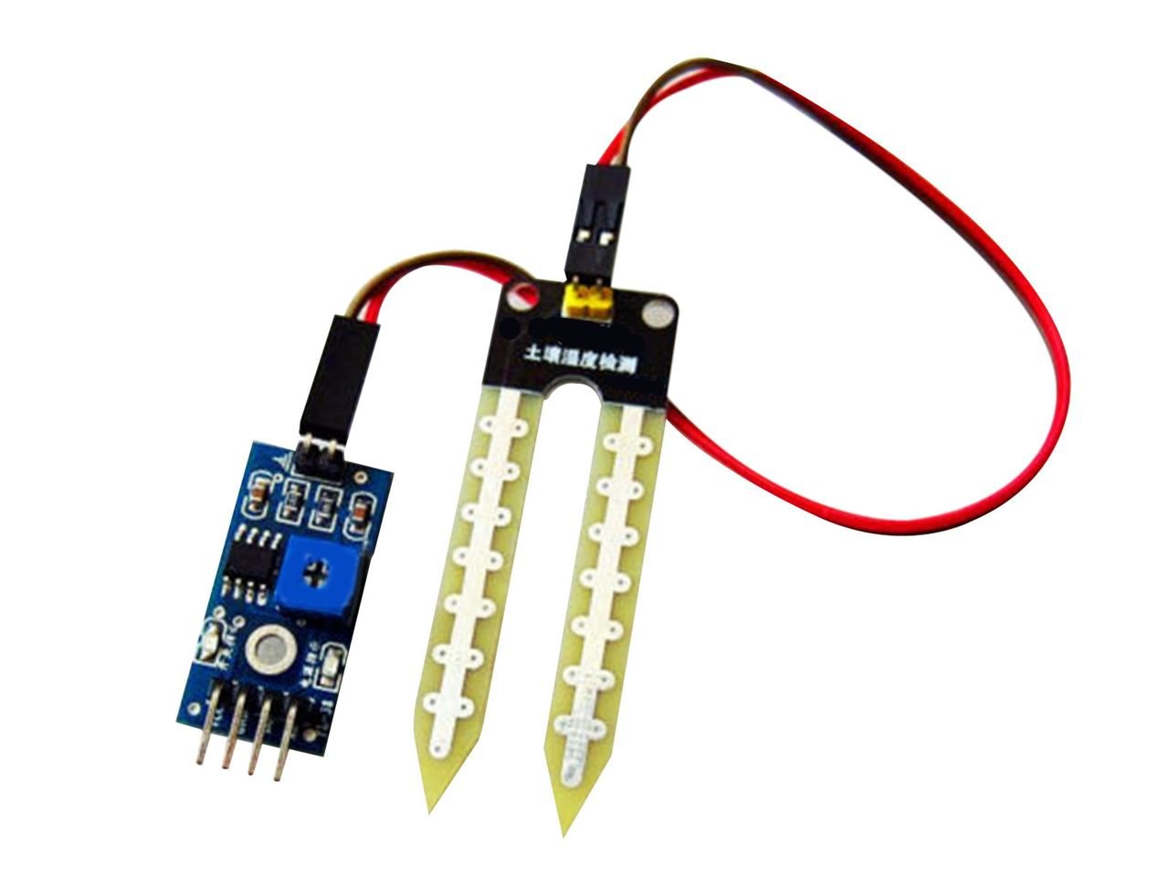

**Specification**

* Working voltage: 5V
* Working Current: <20ma
* Interface: Analog
* Output voltage signal: 0~4.2V
* Depth of detection: 37mm
* Working Temperature: 10℃~30℃
* Size: 63×20×8mm
* Arduino compatible interface
* Low power consumption
* High sensitivity

**Why we use the Inductor and capacitor ?**

the inductor (L) and capacitor (C1) connected to the output of the moisture sensor form a **low-pass filter**:

1. **Noise Reduction**: The moisture sensor output can have high-frequency noise, especially when it's exposed to electrical interference from other components or the environment. The low-pass filter allows low-frequency signals (which are typically the signals of interest, like the moisture level) to pass through while attenuating (reducing) high-frequency noise.

2. **Signal Smoothing**: The capacitor and inductor work together to smooth out fluctuations in the sensor's output, providing a more stable and consistent signal. This is important because it ensures that the input to any subsequent processing stages (like an analog-to-digital converter or a microcontroller) is clean and represents the actual moisture level more accurately.

3. **Improved Accuracy**: By reducing noise and stabilizing the signal, the accuracy of the moisture readings can be improved, leading to more reliable operation of the pump or other components controlled by the sensor.

In summary, the inductor and capacitor are used to create a low-pass filter that helps to clean up the sensor's output, reducing noise and improving the accuracy of the readings.